Madison Investment and Insurance Committee update
13 August 2020

The virus
Chart 1 below shows the latest figures for new cases per week for several countries over the past month. Last week saw further increases in COVID-19 infections in several countries. In Australia, as of 12 August 2020, a total of 21,713 cases of COVID-19 have been reported, including 331 deaths. New cases on 11 August were 353. Of the newly reported cases, the majority continue to be in Victoria. Optimism for the development of a COVID-19 vaccine has been offset by continued tension between the U.S. and China.

Chart 1 – Daily confirmed COVID-19 cases
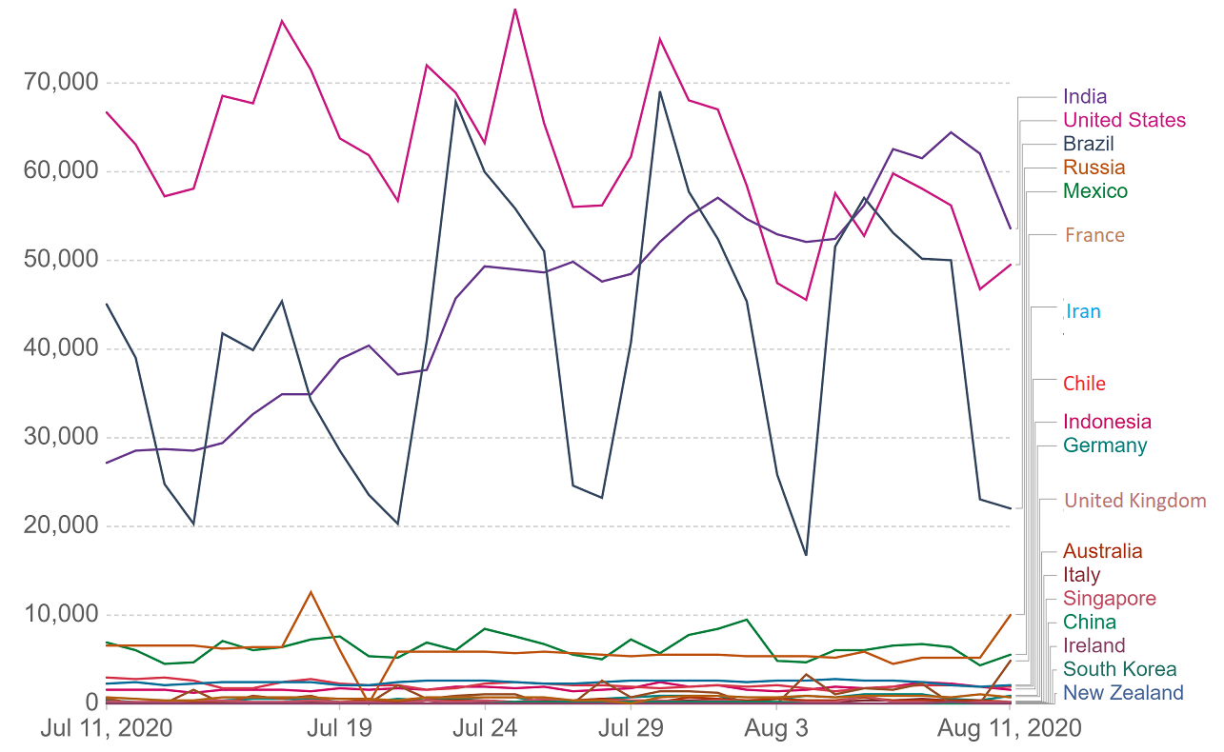
Source: European Centre for Disease Prevention and Control

The economics
- U.S. jobless claims rose by 1,186,000 for the week prior. This is a decrease of 249,000 from the previous week's revised level. Chart 2 shows the pace of jobless claims on a weekly basis.. The August non-farm payrolls will show the potential impact from the second wave of COVID-19 shutdowns.
- The U.S. Federal Reserve (Fed) left its benchmark interest rate unchanged at its two-day meeting, which ended July 29. The Fed reiterated its commitment to bond purchases along with the lending and liquidity programs it currently has in place.
- The Australian Government announced JobKeeper '3.0' will cost a further AUD15.6 billion. The new spending reflects both the cost of the lockdowns in Victoria, as well as an easing in the national eligibility criteria. The new program brings the total Australian Government fiscal stimulus up to AUD232 billion (+12% of annual GDP). This is more than double the global average (+5.2%).

Chart 2 – US Initial Jobless Claims
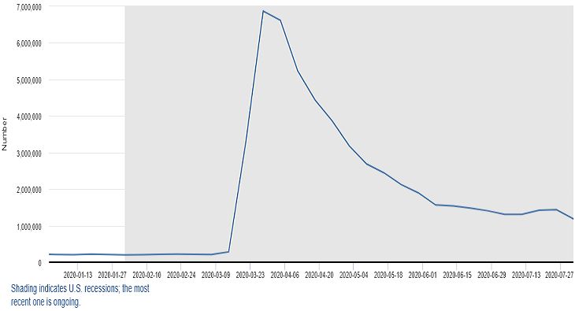
Source: Federal Reserve Bank of St. Louis - U.S. Employment and Training Administration

The markets
- Stock prices rallied in July as further development of a COVID-19 vaccine and better-than-expected corporate financial reports out of the U.S. encouraged investors. The S&P 500 gained 5.5 percent.
- As of July 31, more than half of the companies comprising the S&P 500 Index reported their earnings. Of these companies, 84 percent reported earnings above analysts’ estimates, with the Health Care and Technology sectors leading the way.
- Overseas markets were mixed. European stocks trended lower as multiple economies continued to reopen, and the European Union agreed to a fiscal stimulus package for member nations. German shares edged higher, while France lost ground. Australian markets rose 0.51%, while Japan fell 2.59%.
President Trump's resumption of the president's daily briefings has enabled him to narrow the gap between him and Democratic nominee Joe Biden from 9% to just over 6%. Trump has also recently taken an even more aggressive tone on China which has included executive orders prohibiting US residents from doing business with TikTok, WeChat, or the apps' Chinese owners. Separately, the Trump administration recommended a plan that would force Chinese companies with shares traded on US stock exchanges to give up their listings unless they comply with US audit requirements by 2022.

From here, the investment environment is likely to be a challenging one. The United States 30-year treasury rate has fallen from 2.3% to 1.3%, with the 10-year rate falling from 1.8% to 0.6%. This all points to an economic outlook that is significantly worse than it was at the beginning of 2020 and markets expect interest rates to below for a long period.
COVID-19 has caused long-term damage to many economies. We are yet to realise the full extent of its impact. Even now, Australia is experiencing a second wave of infections and associated restrictions, while the virus is still spreading rapidly across the United States, Brazil, India, and Russia.

Normally big, macroeconomic events like this shock, tend to accelerate trends that were already in place before, serving as a catalyst. Characteristics of a post-COVID world may include:
- Deglobalization – this was already in motion before the current crisis. There was a trade war. We saw many companies trying to bring some of the global supply chains, closer to home. This trend will likely accelerate.
- Increased income and wealth inequality – persistent recessions usually hit the weakest parts of society the most.
- Improvement in household savings – individuals will be more cautious in terms of their spending. We can see an uptick in this already in chart 3.
- Closer cooperation of monetary and fiscal policy – we are and will continue to see governments and central banks working hand-in-hand. Central banks will need to continue to help governments absorb additional debt. This is likely here to stay.
- Lower interest rates - both nominal and real interest rates are likely to remain low for an extended period.

Chart 3 – Household Income, consumption, and savings
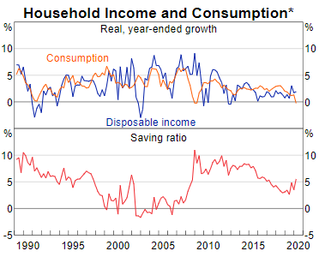

Things to consider
- If you have several working years ahead (e.g. you are under 55 years old)
If you still have an extended period to invest, the long-term outlook is still strong. The economic impact of COVID-19 doesn’t point to fundamental underlying weakness, but rather to an external shock that has caused a dislocation. The longer the lockdown continues, the higher the likelihood of permanent economic damage, but the global economy was in reasonable shape heading into this pandemic and should show resilience as time passes.
- If you are nearing retirement (e.g. you are over 55 years old)
If you are approaching retirement you should consider your tolerance for investment risk as the returns during the next few years might continue to be volatile. It would be prudent to expect low inflation and low interest rates for the foreseeable future.
- If you are already retired or on a pension
Clients who are in retirement and drawing down should consider their investment choice. While inflation should remain low, reducing the cost of living pressures on retirees, defensive investment options may not provide a meaningful level of income over the next few years. Even in retirement, superannuation can be a long-term investment.

This document and its contents are general in nature and do not constitute or convey personal advice. It has been prepared without consideration of anyone’s financial situation, needs, or financial objectives. Formal advice should be sought before acting on the areas discussed. This document is a private communication and is not intended for public circulation other than to authorised representatives of the Madison Financial Group and their clients. The authors and distributors of this document accept no liability for any loss or damage suffered by any person as a result of that person, or any other person, placing any reliance on the contents of this document.

Australian Government Department of Health – Coronavirus (COVID-19) at a glance
United States of America Department of Labor – News release
CNBC.com, July 29, 2020
The Wall Street Journal, July 31, 2020
FactSet Research, July 31, 2020
MSCI.com, July 31, 2020
CNBC.com, August 31, 2019 and MarketWatch, August 1, 2019

